Replace and modernize legacy VPN architectures with a cloud-native Zscaler Zero Trust solution to reduce attack surface and lateral movement.

S.NO | NAME | COLLEGE NAME | EMAIL ID
1. | Gayathiri M | Adharsh Vidhyalaya College of Arts and Science for Women | gayathirinishanth@gmail.com
2. | Kavidharshini D | Adharsh Vidhyalaya College of Arts and Science for Women | kavidharshinikala@  gmail.com
3. | Harini Sri S | Adharsh Vidhyalaya College of Arts and Science for Women | harigobi54@gmail.com
4. | Jeevalatha N | Adharsh Vidhyalaya College of Arts and Science for Women | jeevalathanagarai344@  gmail.com
List of Teammates:-

Project Details

Title of the Project:-

Replace and modernize legacy VPN architectures with a cloud-native Zscaler Zero Trust solution to reduce attack surface and lateral movement.
Project Overview:-
This project focuses on replacing traditional VPN (Virtual Private Network) architectures with a modern cloud-native Zero Trust security model using Zscaler. Traditional VPNs allow users to connect directly to the internal network, which can increase the risk of cyberattacks, unauthorized access, and lateral movement inside the network.
The proposed system uses Zero Trust Architecture, where no user or device is trusted by default, even if they are inside the network. Every access request is verified based on identity, device security, and context before granting access to applications.
By implementing Zscaler’s cloud security platform, users can securely access applications from anywhere (office, home, or mobile) without exposing the internal network. Instead of connecting to the whole network like VPN, users connect only to the specific application they need, which significantly reduces the attack surface and prevents attackers from moving across systems.
This approach improves security, scalability, performance, and user experience while simplifying network management. It also helps organizations adopt secure remote work, cloud applications, and modern digital infrastructure.

Abstract:-
This project details the strategic migration from a legacy Virtual Private Network (VPN) infrastructure to a cloud-native Zero Trust Network Access (ZTNA) solution provided by Zscaler. The primary driver for this initiative is the fundamental inadequacy of traditional VPNs in the modern threat landscape. Legacy architectures operate on a "connect first, verify later" model, granting users broad access to the corporate network and, consequently, creating a significant risk of lateral movement by malicious actors. This expansive attack surface, combined with the operational overhead of managing physical appliances and the poor user experience associated with hair-pinned traffic, renders the existing model both insecure and inefficient for today's hybrid workforce.

The proposed solution leverages the Zscaler Zero Trust Exchange, a global, cloud-native platform that shifts connectivity from a network-centric to an identity and application-centric model. By making corporate applications invisible to the internet and establishing direct, secure connections between verified users and specific applications, the new architecture eliminates the concept of network-based privileges. This approach ensures that users connect to the applications they need, not the underlying network, thereby completely neutralizing the threat of lateral movement. Furthermore, it improves performance by steering traffic directly to Zscaler’s edge nodes, optimizing the user experience regardless of their location.

The expected outcomes of this modernization project are multifaceted. We anticipate a drastic reduction in the organization's attack surface and the complete elimination of lateral movement risks. This will be coupled with a simplified, scalable security posture managed from a unified cloud console, reducing operational costs and complexity. Ultimately, this transition will not only fortify our cyber defenses against sophisticated threats but also enable a secure, high-performance, and agile work environment, future-proofing the organization's security architecture. By replacing traditional VPN connectivity with Zscaler’s secure cloud platform, users can access applications directly without exposing the entire internal network. This approach minimizes the attack surface, prevents lateral movement within the network, and enhances overall cybersecurity. Additionally, it provides secure and scalable access for remote users, supports modern cloud environments, and improves performance and user experience.

Use Case Scenarios:

Scenario 1: Third-Party Vendor Access to Finance Application

An external auditor needs temporary access to the university's finance application for end-of-year reconciliation. Instead of provisioning a VPN account, ZPA grants time-bound, application-specific access. The vendor authenticates via identity provider and is micro-segmented away from all other internal resources.

Output:

- User identity verified (External_Auditor_Group)

- Time-bound access policy enforced (7-day validity)
- Connection restricted to Finance Application only
- No lateral movement possible to other systems

Scenario 2: Research Assistant Access to High-Performance Computing Cluster

A graduate student requires SSH access to an on-premises research computing cluster to run data analysis scripts. Using ZPA, they connect directly to the cluster without exposing SSH ports to the internet or requiring a full network-level VPN tunnel.

Output:

- User identity verified (Research_Assistant_Group)
- Protocol-specific access granted (SSH only)
- Direct micro-tunnel established to HPC Cluster
- All other network segments remain inaccessible

Scenario 3: Administrative Staff Access to Internal File Server

An administrative assistant working from a campus satellite office needs to access a sensitive file server containing student records. ZPA verifies their device compliance and routes them exclusively to the file server application, with all traffic inspected inline for data loss prevention.

Output:

- User identity verified (Admin_Staff_Group)
- Device posture compliant (Disk encryption enabled, patch level current)
- Granular file access policies enforced (Read/Write permissions)
- Data Loss Prevention (DLP) policies active

Scenario 4: IT Administrator Secure Access to Server Management Interfaces

A systems administrator requires RDP access to manage critical Windows servers in the data center. Using ZPA, they connect directly to the target servers without exposing RDP to the internet, while all administrative sessions are recorded for audit compliance.

Output:

- User identity verified (IT_Admin_Group)
- Privileged access workflow triggered (Approval required)
- Session recording and monitoring active
- Micro-tunnel established to specific server IP and port only

Scenario 5: Visiting Professor Access to Library Resources

A visiting professor from a partner institution needs temporary access to digitized archives stored on an internal library application server. ZPA provides just-in-time access without placing the visiting scholar on the internal network, ensuring separation from administrative systems.

Output:

- User identity verified (Visiting_Faculty_Group)
- Just-in-time access provisioned (8-hour session limit)
- Connection restricted to Library Application Server
- Full network segmentation maintained

Stage-1
Title of the Project: -
Replace and modernize legacy VPN architectures with a cloud-native Zscaler Zero Trust solution to reduce attack surface and lateral movement.
Overview:-
This project is a strategic initiative to fundamentally transform the organization's remote access and network security architecture by decommissioning the existing legacy Virtual Private Network (VPN) infrastructure and replacing it with a cloud-native Zero Trust solution from Zscaler. The current VPN model, based on a perimeter-centric "castle-and-moat" approach, inherently trusts users once they are connected, granting them broad access to the internal network. This expansive access creates a significant attack surface and leaves the organization vulnerable to lateral movement, where a single compromised credential can lead to a widespread breach. The operational challenges of managing, scaling, and patching legacy VPN appliances, coupled with the poor user experience of backhauled traffic, further underscore the urgent need for modernization. This project directly addresses these critical security and operational deficiencies.

The core of the new architecture is Zscaler Private Access (ZPA), which operates on a Zero Trust principle of "never trust, always verify" and "connect the user to applications, not the network." By making internal applications completely invisible to the internet and the public DNS, ZPA eliminates the attack surface associated with exposed ports and IP addresses. When a user requests access, ZPA verifies their identity and context—through integrations with identity providers like Azure AD and device posture checks—before establishing a secure, encrypted micro-tunnel. Crucially, this tunnel connects the user only to the specific application they are authorized to use, not to the underlying network. This effectively renders the network invisible to the end-user and eliminates any possibility of lateral movement, as threat actors cannot scan, discover, or pivot to other internal resources.

The anticipated outcomes of this modernization are profound and multi-faceted. The organization will achieve a drastically reduced attack surface and a complete eradication of lateral movement risks, significantly strengthening its security posture against advanced cyber threats. Operationally, the shift to a cloud-native, globally distributed edge removes the need for traffic hair-pinning, thereby optimizing performance and user experience for a hybrid workforce. This transition also simplifies IT operations by replacing complex, hardware-dependent VPN infrastructure with a unified, scalable, and agile cloud management console. Ultimately, this project will not only fortify the organization's defenses but also create a secure, high-performance, and future-ready access framework that supports evolving business needs.
This expansive access creates a significant attack surface and leaves the organization vulnerable to lateral movement, where a single compromised credential can lead to a widespread breach. The operational challenges of managing, scaling, and patching legacy VPN appliances, coupled with the poor user experience of backhauled traffic, further underscore the urgent need for modernization. This project directly addresses these critical security and operational deficiencies.
The core of the new architecture is Zscaler Private Access (ZPA), which operates on a Zero Trust principle of "never trust, always verify" and "connect the user to applications, not the network." By making internal applications completely invisible to the internet and the public DNS, ZPA eliminates the attack surface associated with exposed ports and IP addresses. When a user requests access, ZPA verifies their identity and context—through integrations with identity providers like Azure AD and device posture checks—before establishing a secure, encrypted micro-tunnel. Crucially, this tunnel connects the user only to the specific application they are authorized to use, not to the underlying network. This effectively renders the network invisible to the end-user and eliminates any possibility of lateral movement, as threat actors cannot scan, discover, or pivot to other internal resources.

List of Vulnerability Table:

S.NO | CATEGORY NAME | VULNERABILITY  NAME | CWE/CVE-NO
1. | Broken Access Control | Relative Path Traversal | CWE-23
2. | Security Misconfiguration | External Control of System or Configuration Setting | CWE-15
3. | Software Supply Chain Failures | Unimplemented or Unsupported Feature in UI | CWE-447
4. | Cryptographic Failures | Weak Encoding for Password | CWE-261
5. | Injection | Improper Input Validation | CWE-20
6. | Insecure Design | Improper Privilege Management | CWE-269
7. | Authentication Failures | Empty Password in Configuration File | CWE-258
8. | Software or Data Integrity Failures | Missing Support for Integrity Check | CWE-353
9. | Security Logging & Alerting Failures | Insufficient Logging | CWE-778
10. | Mishandling of Exceptional Conditions | Improper Handling of Extra Parameters | CWE-235

Report:-
- Vulnerability Name : Relative Path Traversal

- CWE Number: CWE-23

- OWASP Category : Broken Access Control

- Description :

Relative Path Traversal is a vulnerability that occurs when an application does not properly validate user input used in file paths. Attackers can manipulate the file path using characters like ../ to access files and directories outside the intended folder. This may allow unauthorized users to read sensitive system files or application data.

- Business Impact:

This vulnerability can allow attackers to access confidential files stored on the server. Sensitive information such as configuration files, passwords, or system data may be exposed. This may lead to data breaches, privacy violations, and loss of customer trust.

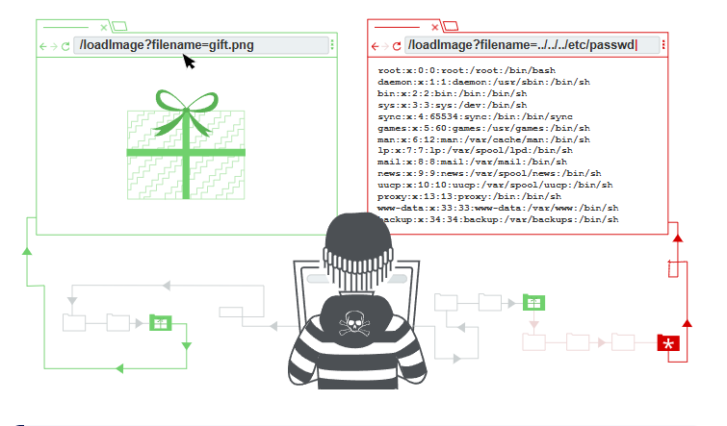

Recommendation:
- Input Validation – Validate and sanitize user inputs used in file paths to prevent malicious characters.
- Use Whitelisting – Allow only specific files or directories that are required by the application.
- Restrict File Permissions – Configure proper file access permissions to protect sensitive files.
- Secure File Handling – Avoid directly using user input in file operations.
2) Vulnerability Name: External Control of System or Configuration Setting
CWE Number:CWE-15
OWASP Category: Security Misconfiguration
Description:This vulnerability occurs when external users are able to modify system configuration settings without proper validation. If attackers gain control over configuration parameters, they may change system behavior or security settings.
Business Impact: Attackers may manipulate system configurations and disable important security controls. This can lead to unauthorized access, system misuse, or service disruption. It may also affect the reliability and stability of the system.
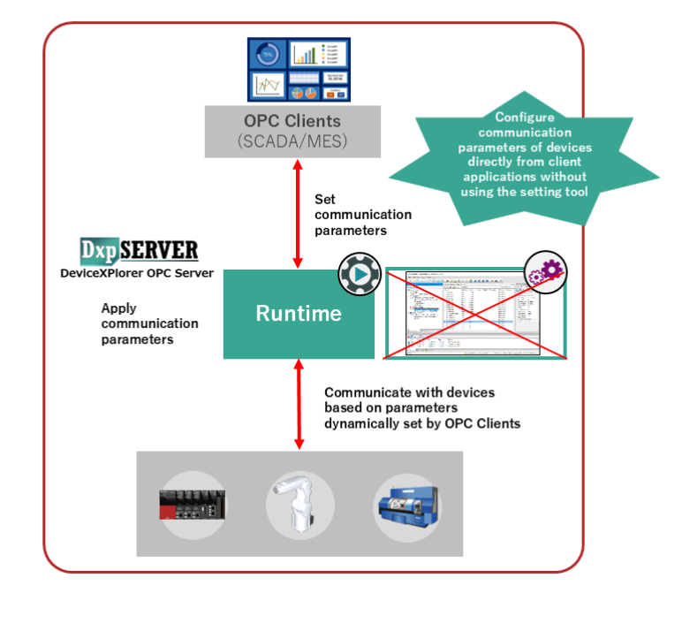

Recommendation:
- Restrict Configuration Access – Allow only authorized users to modify system settings.
- Input Validation – Validate all external inputs used for configuration parameters.
- Secure Configuration Storage – Store configuration settings in secure locations.
- Access Control – Implement strong authentication and authorization mechanisms.

3) Vulnerability Name: Unimplemented or Unsupported Feature in UI
CWE Number: CWE-447

OWASP Category: Software Supply Chain Failures
Description: This vulnerability occurs when the user interface contains features or options that are not properly implemented or supported by the system. Attackers may exploit these features to gain unintended access or information.
Business Impact: Unimplemented features can create security loopholes in the system. Attackers may use these weaknesses to bypass security controls or cause unexpected behavior in the application.
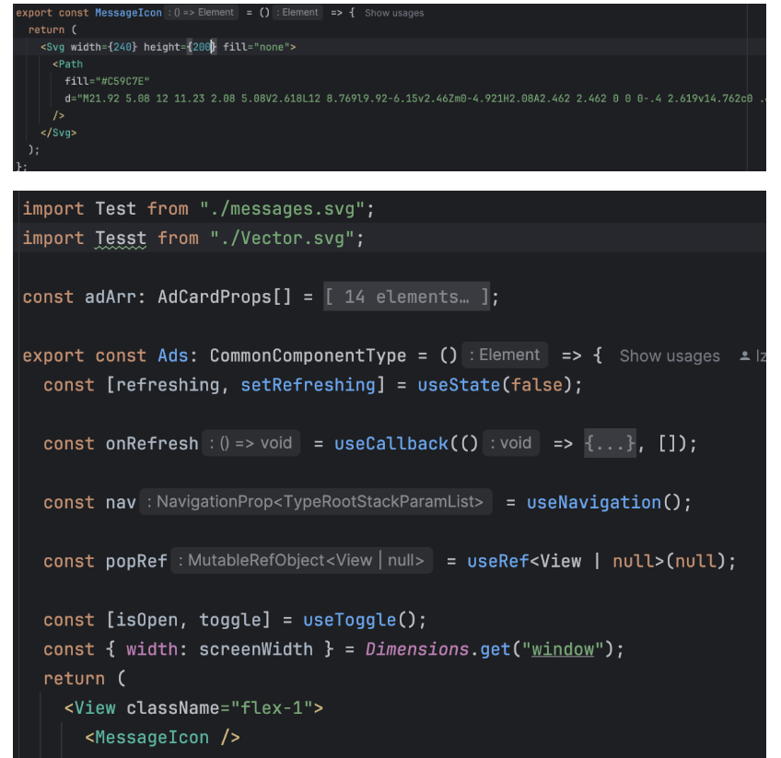

Recommendation:
- Remove Unused Features – Disable or remove unsupported UI features.
- Proper Testing – Ensure all UI features are fully tested before deployment.
- Secure Development Practices – Follow secure coding guidelines during development.
- Regular Security Review – Periodically review UI components for vulnerabilities.
4) Vulnerability Name: Weak Encoding for Password
CWE Number: CWE-261
OWASP Category: Cryptographic Failures
Description: This vulnerability occurs when passwords are stored using weak encoding or encryption methods. Weak password protection allows attackers to easily decode or crack user credentials.
Business Impact: If attackers gain access to encoded passwords, they may crack them and obtain user accounts. This can lead to unauthorized access, account compromise, and data breaches.

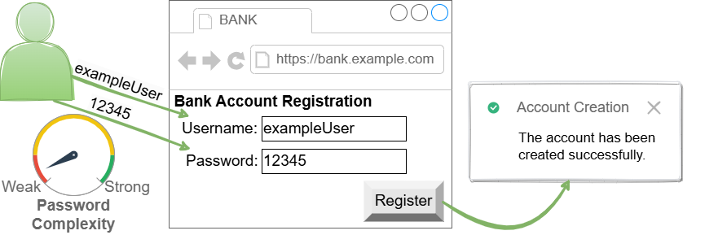

Recommendation:
- Strong Encryption – Use strong hashing algorithms like bcrypt or SHA-256.
- Password Salting – Add unique salts to passwords before hashing.
- Secure Storage – Avoid storing passwords in plain text or weak encoding.
- Regular Security Updates – Update encryption methods regularly.
5) Vulnerability Name: Improper Input Validation
CWE Number: CWE-20
OWASP Category: Injection
Description: Improper Input Validation occurs when an application fails to properly validate user input. Attackers can send malicious input to exploit the system and perform unauthorized actions.
Business Impact: Attackers may inject malicious data into the application, leading to system compromise or data manipulation. This can result in data loss, system damage, or unauthorized access.
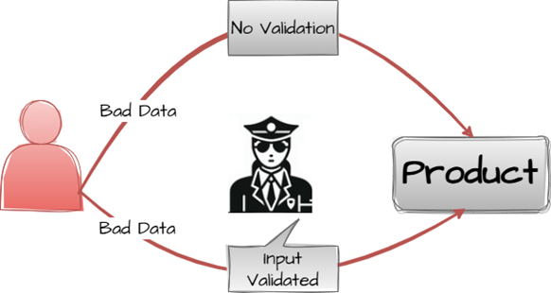

Recommendation:
- Input Validation – Validate all user inputs before processing.
- Use Input Filtering – Block malicious characters and scripts.
- Server-Side Validation – Perform validation on the server side.
- Secure Coding Practices – Follow secure programming standards.
6) Vulnerability Name: Improper Privilege Management
CWE Number: CWE-269
OWASP Category: Insecure Design
Description: Improper Privilege Management occurs when an application does not correctly control user permissions and access levels. Users may obtain privileges that are higher than their authorized role. This can happen due to weak access control mechanisms or incorrect privilege assignment. As a result, unauthorized users may perform restricted actions within the system.
Business Impact: This vulnerability can allow users or attackers to access sensitive information or perform unauthorized operations. It may lead to data manipulation, data leakage, or system misuse. Such incidents can affect system security, cause financial loss, and damage the organization’s reputation.
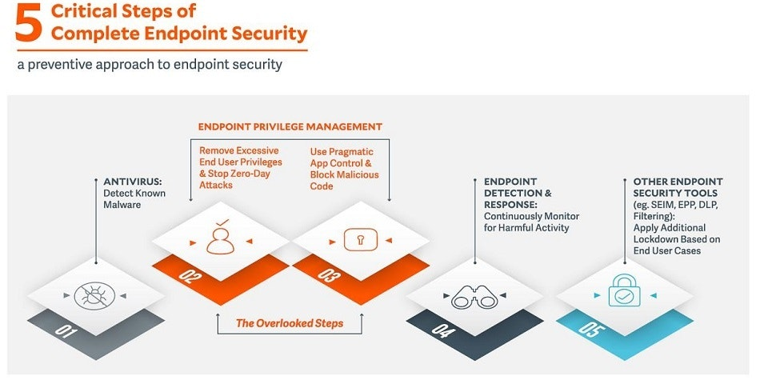
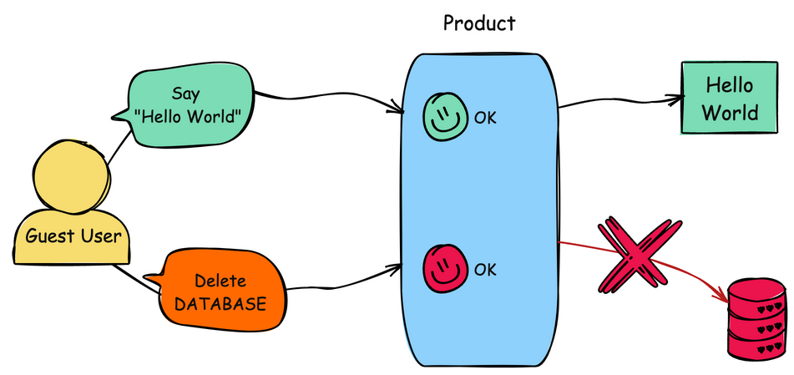

Recommendation:
1) Role-Based Access Control
Assign permissions based on user roles so that each user can only access resources required for their role.
2) Least Privilege Principle
Provide users with only the minimum level of access necessary to perform their tasks.
3) Regular Permission Review
Periodically review and update user permissions to ensure that no user has unnecessary or excessive privileges.

7) Vulnerability Name: Empty password in Configuration file
CWE Number: CWE-258
OWASP Category: Authentication Failure
Description: Empty Password in Configuration File occurs when system or application configuration files contain accounts with no password set. This means authentication is not properly enforced. Attackers can easily access the system or services without providing credentials. Such weak security settings increase the risk of unauthorized access.
Business Impact: This vulnerability can allow attackers to access sensitive systems or services without authentication. It may lead to unauthorized data access, system misuse, or configuration changes. Such incidents can cause security breaches and loss of confidential information.
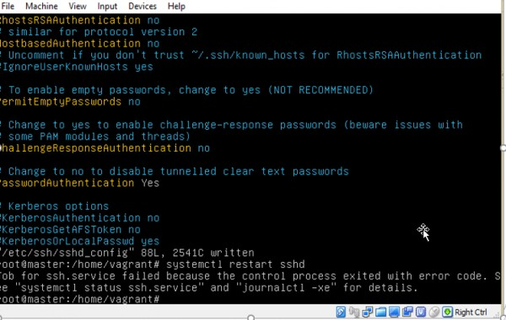
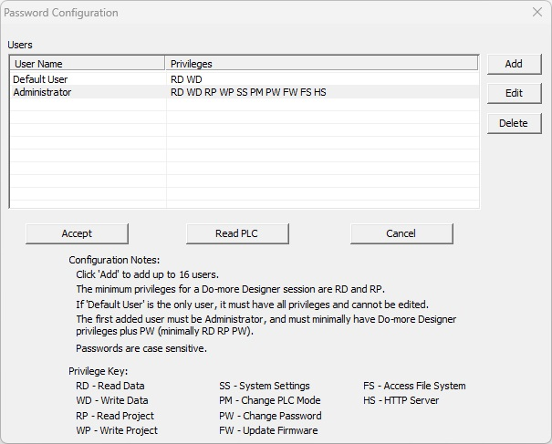

Recommendation:
1) Use Strong Passwords
Ensure that all accounts defined in configuration files use strong and complex passwords.
2) Secure Configuration Files
Restrict access permissions so that only authorized administrators can view or modify configuration files.
3) Encrypt Sensitive Credentials
Store passwords in encrypted or hashed format instead of plain text to improve security.
4) Regular Security Audits
Perform periodic security checks to identify configuration files with weak or empty passwords.
5) Disable Unused Accounts
Remove or disable accounts that are not required to reduce security risks.

8) Vulnerability Name: Missing Support for Integrity Check
CWE Number: CWE-353
OWASP Category: Software or data integrity failures
Description: Missing Support for Integrity Check occurs when a system does not verify whether data or files have been modified during storage or transmission. Without integrity verification mechanisms, unauthorized changes may go undetected. Attackers can alter files or data without the system identifying the modification.
Business Impact: This vulnerability may allow attackers to modify important data or system files. It can lead to incorrect information, system malfunction, or loss of data reliability. Such issues may affect business operations and reduce trust in the system.
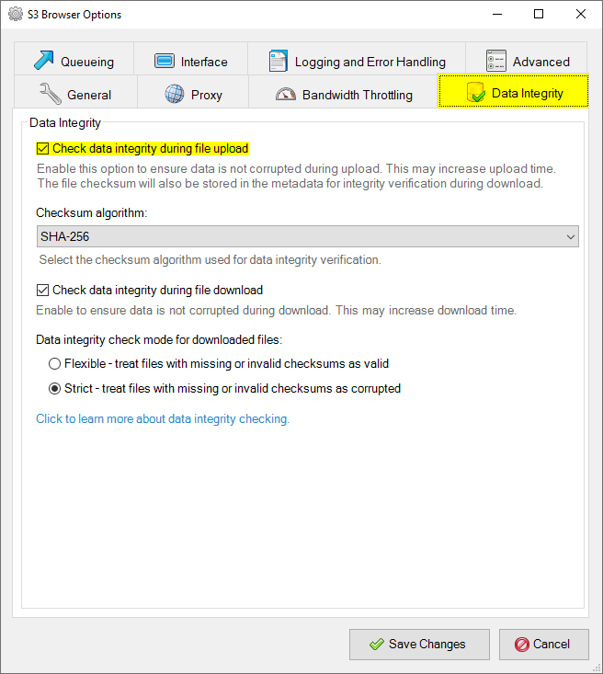

Recommendation:
1) Use Hash Functions
Implement hash algorithms such as SHA-256 to verify the integrity of files and data.
2) Digital Signatures
Use digital signatures to ensure that files or messages are not altered during transmission.
3) Secure File Storage
Protect critical files from unauthorized modification using proper access controls.
4) Integrity Monitoring
Use monitoring tools to detect unexpected changes in important files or system data.
5) Regular Security Testing
Conduct periodic integrity checks and security audits to ensure data has not been tampered with.

9) Vulnerability Name: Insufficient Logging
CWE Number: CWE-778
OWASP Category: Security logging & Alerting Failures
Description: Insufficient Logging occurs when an application or system does not properly record important user activities or security events. Without adequate logging, suspicious actions and security incidents may go unnoticed. Attackers can perform malicious activities without leaving sufficient evidence in system logs.
Business Impact: This vulnerability makes it difficult to detect and investigate security incidents. Unauthorized activities may remain unnoticed for a long time. As a result, it may increase the impact of cyber attacks and affect system security and business operatio

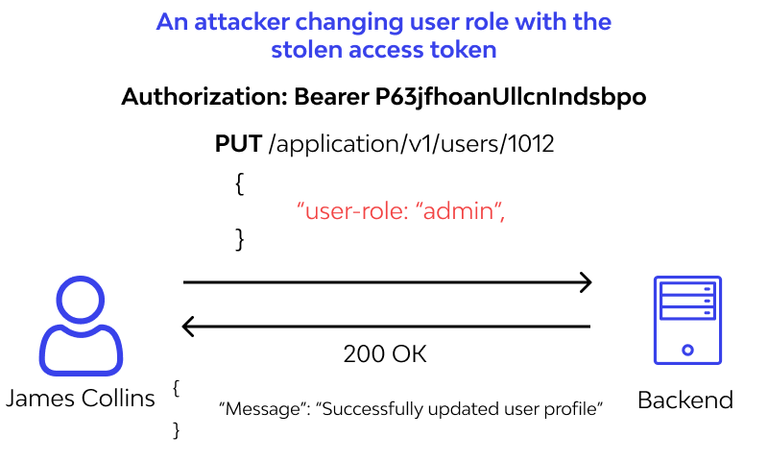
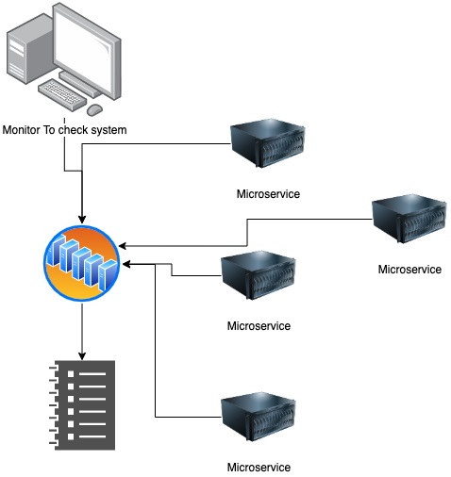

Recommendation:
1) Enable Security Logging
Ensure that important system activities, login attempts, and errors are properly recorded in logs.
2) Log Monitoring
Regularly monitor and review system logs to detect suspicious or unusual activities.
3) Secure Log Storage
Protect log files from unauthorized access or modification.
4) Centralized Logging System
Use centralized log management systems to collect and analyze logs efficiently.
5) Regular Log Audits
Periodically audit logs to identify potential security threats and vulnerabilities.

10) Vulnerability Name: Improper handling of extra parameters
CWE Number: CWE-235
OWASP Category: Mishandling of exceptional conditions
Description:
Improper Handling of Extra Parameters occurs when an application does not properly validate or control unexpected parameters in user requests. Attackers may send additional parameters that are not required by the application. If these parameters are not properly handled, they may influence system behavior or bypass certain validations.
Business Impact:
This vulnerability may allow attackers to manipulate application functionality or bypass security controls. It can lead to unauthorized actions, incorrect data processing, or exposure of sensitive information. Such issues may affect system reliability and application security.

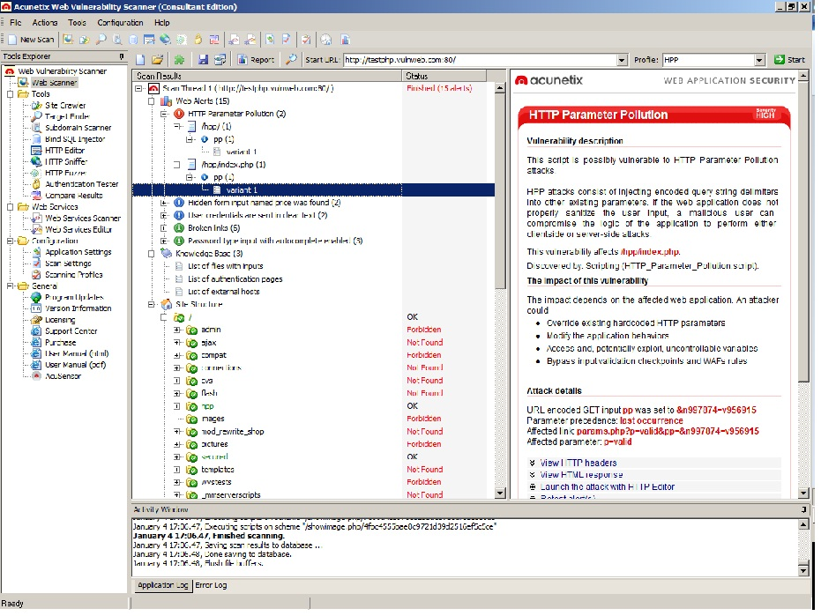

Recommendation:
1) Parameter Validation
Validate all request parameters and ensure only expected inputs are processed by the application.
2) Reject Unexpected Inputs
Ignore or block extra parameters that are not defined or required by the system.
3) Secure API Design
Design APIs and application logic to strictly control accepted parameters.
4) Input Filtering
Filter and sanitize user inputs before processing them.
5) Regular Security Testing
Conduct vulnerability testing to identify and fix issues related to parameter handling.

STAGE 2

Title: Nessus Scan
Overview:
Nessus is a widely used vulnerability assessment tool developed by Tenable Inc. It is designed to identify security weaknesses in computer systems, networks, and web applications. Nessus helps security professionals detect vulnerabilities before attackers exploit them. It performs automated scans to discover misconfigurations, outdated software, and known security vulnerabilities.
Nessus works as a remote vulnerability scanner, which means it does not necessarily need to be installed on the target system to perform a scan. Instead, it sends different types of probes and requests to the target host. These probes help identify the operating system, running services, open ports, and potential vulnerabilities present in the system.
The tool uses a plugin-based architecture where each plugin is responsible for checking a specific vulnerability. Nessus contains thousands of plugins that are regularly updated to detect newly discovered vulnerabilities. These plugins help analyze systems for security issues in operating systems, applications, databases, and network devices.
When a scan is initiated, Nessus first performs a discovery process to identify the target system and its services. After identifying the system details, Nessus runs multiple vulnerability checks using its plugins. Once the scan is completed, the tool generates a detailed report that includes information about the detected vulnerabilities, their severity level, potential risks, and recommended remediation steps.
Nessus is commonly used by organizations, cybersecurity professionals, and security researchers to perform vulnerability assessments and strengthen system security. It helps organizations identify security gaps and take corrective actions to protect their infrastructure from cyber threats.

How Nessus Works
Nessus follows a systematic process to identify vulnerabilities in systems and networks. The scanning process usually includes the following steps:
- Target Identification
Nessus first identifies the target system, which may include a single host, a group of hosts, or an entire network. The user provides the target IP address or domain name for scanning.
- Port Scanning
Nessus scans the target system to detect open ports and running services. This helps in identifying the services that may contain vulnerabilities.
- Service Detection
After identifying open ports, Nessus determines which services and applications are running on those ports. This helps in analyzing the system environment.
- Vulnerability Detection
Nessus runs a large number of security plugins to check for known vulnerabilities in the operating system, applications, and network services.
- Risk Analysis and Reporting
Once the scanning process is complete, Nessus generates a detailed report that classifies vulnerabilities based on severity levels such as Low, Medium, High, and Critical. The report also includes recommendations to fix the identified vulnerabilities.

Applications of Nessus:
Nessus can be used in various cybersecurity activities, including:
- Network Security Assessment – Scans network devices to detect vulnerabilities and misconfigurations.
- Web Application Scanning – Identifies security weaknesses in websites and web applications.
- Compliance Auditing – Helps organizations check whether systems meet security compliance standards.
- Configuration Assessment – Detects insecure system configurations and security misconfigurations.
- Vulnerability Management – Helps organizations continuously monitor and manage security vulnerabilities.
Target website: https://testfire.net
Target ip address: 65.61.137.117
List of Vulnerability:
S.No | Vulnerability Name | Severity | Plugins
1. | TLS Version 1.0 Protocol Detection | MEDIUM | 104743
2. | TLS Version 1.1 Deprecated Protocol | MEDIUM | 157288
3. | SSL/TLS Diffie-Hellman Modulus <= 1024 Bits (Logjam) | LOW | 83875
4. | HTTP Server Type and Version | INFO | 10107
5. | HyperText Transfer Protocol (HTTP) Information | INFO | 24260
6. | HSTS Missing From HTTPS Server | INFO | 84502
7. | SSL Certificate Information | INFO | 10863
8. | SSL Cipher Block Chaining Cipher Suites Supported | INFO | 70544
9. | Additional DNS Hostnames | INFO | 46180
10. | Device Type | INFO | 54615
Report:

1) Vulnerability Name: TLS Version 1.0 Protocol Detection

Severity: MEDIUM

Plugin: 104743

Port: 443
Description: The remote service accepts connections encrypted using TLS 1.0. TLS 1.0 has a number of cryptographic design flaws. Modern implementations of TLS 1.0 mitigate these problems, but newer versions of TLS like 1.2 and 1.3 are designed against these flaws and should be used whenever possible.
As of March 31, 2020, Endpoints that aren’t enabled for TLS 1.2 and higher will no longer function properly with major web browsers and major vendors. PCI DSS v3.2 requires that TLS 1.0 be disabled entirely by June 30, 2018, except for POS POI terminals (and the SSL/TLS termination points to which they connect) that can be verified as not being susceptible to any known exploits.

Solution: Enable support for TLS 1.2 and 1.3, and disable support for TLS 1.0.
Business Impact: Continued use of TLS 1.0's encryption, known for its inherent cryptographic flaws, exposes the organization to heightened security risks, increasing the likelihood of data breaches and cyberattacks. This vulnerability jeopardizes compliance with industry standards, specifically PCI DSS v3.2, which mandates the complete cessation of TLS 1.0 use. Non- compliance risks regulatory penalties and erodes customer trust. Moreover, endpoints that lack support for TLS 1.2 and higher will experience impaired functionality with major web browsers and vendors, potentially leading to lost business opportunities and damage to the organization's reputation. Addressing this vulnerability is imperative to mitigate these multifaceted risks and maintain a secure and trustworthy online presence.

2) Vulnerability Name: TLS Version 1.1 Deprecated Protocol
Severity: MEDIUM

Plugin: 157288

Port: 443

Description: The remote service accepts connections encrypted using TLS 1.1. TLS 1.1 lacks support for current and recommended cipher suites. Ciphers that support encryption before MAC computation, and authenticated encryption modes such as GCM cannot be used with TLS 1.1
As of March 31, 2020, Endpoints that are not enabled for TLS 1.2 and higher will no longer function properly with major web browsers and major vendors.
Solution: Enable support for TLS 1.2 and/or 1.3, and disable support for TLS 1.1.
Business Impact: -The continued use of TLS 1.1 with its lack of support for modern cipher suites and advanced encryption methods jeopardizes the organization's security posture, increasing vulnerability to cyber threats and potential data breaches. Additionally, endpoints not upgraded to support TLS 1.2 and higher will encounter compatibility issues with major web browsers and vendors, impacting user experience and potentially leading to missed business opportunities. Swift remediation of this vulnerability is essential to mitigate security risks and ensure seamless interactions with web browsers and vendors, preserving the organization's reputation and operational efficiency.

3) Vulnerability Name: SSL/TLS Diffie-Hellman Modulus <= 1024 Bits (Logjam)
Severity: LOW

Plugin: 83875

Port: 443
Description: - The remote host allows SSL/TLS connections with one or more Diffie-Hellman moduli less than or equal to 1024 bits. Through cryptanalysis, a third party may be able to find the shared secret in a short amount of time (depending on modulus size and attacker resources). This may allow an attacker to recover the plaintext or potentially violate the integrity of connections.

Solution: - Reconfigure the service to use a unique Diffie-Hellman moduli of 2048 bits or greater.
Business Impact: - Allowing SSL/TLS connections with weak Diffie-Hellman moduli raises security concerns. An attacker with sufficient resources and computing power could compromise the shared secret relatively quickly, potentially leading to the decryption of sensitive data or the violation of connection integrity. While the severity is low, the risk of data breaches and integrity compromise should not be underestimated, and it is essential to address this vulnerability to maintain data security and user trust.
4) Vulnerability Name: HTTP Server Type and Version
Severity: INFO
Plugin: 10107
Port: 443
Description: This plugin attempts to determine the type and the version of the remote web server.
Solution: n/a
Business Impact: This relates to the identification of the remote web server's type and version. While this issue doesn't pose an immediate security threat, it can provide valuable information to potential attackers about the server's software stack. Knowledge of the server type and version may aid attackers in exploiting known vulnerabilities specific to that software, making it important to restrict such information from being easily accessible to enhance the server's overall security posture.
5) Vulnerability Name: HyperText Transfer Protocol (HTTPS) information
Severity: INFO
Plugin: 24260
Port: 80
Description: This test gives some information about the remote HTTP protocol - the version used, whether HTTP Keep-Alive is enabled, etc...
This test is informational only and does not denote any security problem.
Solution: n/a
Business Impact: This disclosure of HTTPS information may reveal details about the web server configuration and supported protocols. Attackers can use this information to understand the system environment and identify possible weaknesses. This may help them plan targeted attacks against the server. As a result, it can increase the risk of unauthorized access or exploitation of the system.
6) Vulnerability Name: HSTS Missing from HTTPS Server
Severity: INFO
Plugin: 84502
Port: 443
Description: -The remote HTTPS server is not enforcing HTTP Strict Transport Security (HSTS). HSTS is an optional response header that can be configured on the server to instruct the browser to only communicate via HTTPS. The lack of HSTS allows downgrade attacks, SSL- stripping man-in-the-middle attacks, and weakens cookie-hijacking protections.

Solution: - Configure the remote web server to use HSTS.
Business Impact: -Indicates that the remote HTTPS server does not enforce HTTP Strict Transport Security (HSTS). HSTS is a crucial security feature that, when configured on the server, instructs web browsers to communicate exclusively via HTTPS, enhancing security. The absence of HSTS potentially exposes the server to downgrade attacks, SSL-stripping man-in-the- middle attacks, and weakens protections against cookie hijacking, posing risks to data confidentiality and user security. Enabling HSTS is essential to ensure a higher level of protection for data transmitted between clients and the server.

7) Vulnerability Name: SSL Certificate Information
Severity: INFO
Plugin: 10863
Port: 443
Description: This plugin connects to every SSL-related port and attempts to extract and dump the X.509 certificate.
Solution: n/a
Business Impact: Disclosure of SSL certificate information may reveal details such as certificate issuer, validity period, and encryption type. Attackers may use this information to understand the security configuration of the server. If the certificate is weak or outdated, it may increase the risk of security attacks. This could potentially affect the confidentiality and trust of secure communications.
8) Vulnerability Name: SSL Cipher Block chaining Cipher Suites Supported
Severity: INFO
Plugin: 70544
Port: 443
Description: The remote host supports the use of SSL ciphers that operate in Cipher Block Chaining (CBC) mode. These cipher suites offer additional security over Electronic Codebook (ECB) mode, but have the potential to leak information if used improperly.
Solution: n/a
Business Impact: If the server supports SSL cipher block chaining(CBC) cipher suites, it may be vulnerable to certain cryptographic attacks. Attackers could potentially exploit these weaknesses to intercept or manipulate encrypted communication. This may compromise the confidentiality and integrity of sensitive data transmitted over the network. As a result, it can increase the risk of data leakage or unauthorized access.
9) Vulnerability Name: Additional DNS Hostnames
Severity: INFO

Plugin: 46180

Port: 0
Description: Hostnames different from the current hostname have been collected by miscellaneous plugins. Nessus has generated a list of hostnames that point to the remote host.Note that these are only the alternate hostnames for hosts discovered on a web server.
Solution: If you want to test them, re-scan using the special vhost syntax, such as : www.example.com [192.0.32.10]
Business Impact: This does not pose an immediate threat to business operations or data security. It indicates the discovery of hostnames that are associated with the remote host, particularly in cases of web servers utilizing name-based virtual hosts. While not a security risk on its own, it could be useful for understanding the server's configuration and infrastructure.
Organizations should consider this information as part of their network documentation but do not need to take immediate action to mitigate it as a security threat.

10) Vulnerability Name: Device Type
Severity: INFO

Plugin: 54615
Port: 0
Description: Based on the remote operating system, it is possible to determine what the remote system type is (eg: a printer, router, general-purpose computer, etc).
Solution: n/a
Business Impact: It allows for the identification of the remote system type, such as a printer, router, or general-purpose computer, based on the remote operating system. While this doesn't pose a direct security threat, it offers valuable insights for network administrators to better understand and classify the devices in their network. This information aids in network management, optimization, and ensures that the right security measures are in place for each device type.

Stage 3
Title: Replace and modernize legacy VPN architectures with a cloud-native Zscaler Zero Trust solution to reduce attack surface and lateral movement
Overview:

1. Introduction:
Organizations traditionally used Virtual Private Networks (VPNs) to allow remote users to access internal networks. However, as cyber threats increase and remote work becomes more common, legacy VPN architectures create security challenges. Attackers can exploit VPN access to move laterally across networks and compromise sensitive systems. To overcome these risks, organizations are adopting Zero Trust architecture using cloud-native security platforms such as Zscaler.
In modern organizations, secure remote access to corporate networks is very important. Traditionally, companies used Virtual Private Networks (VPNs) to allow employees to connect to internal systems from remote locations. However, legacy VPN architectures have several security limitations. Once a user is connected to the VPN, they may gain broad access to internal network resources, which increases the risk of cyber attacks and unauthorized access. Attackers who compromise a single device can move laterally within the network and access sensitive data.
To overcome these challenges, modern security models such as Zero Trust Architecture are being adopted. The Zero Trust model is based on the principle of “never trust, always verify.” This approach ensures that every user and device must be authenticated and authorized before accessing any resource. In this project, the focus is on replacing traditional VPN infrastructure with a cloud-based Zero Trust solution using Zscaler technology. The cloud-native Zero Trust platform helps reduce the attack surface and prevents lateral movement within the network.

2. Objective of the Project:
The main objective of this project is to modernize legacy VPN architectures by implementing a cloud-based Zero Trust solution. Traditional VPN systems provide full network access once a user logs in, which can expose internal resources to potential threats. The goal of this project is to improve network security by implementing a more controlled and secure access model.
Another objective is to reduce the attack surface of the organization’s network infrastructure. By adopting the Zero Trust approach, users are granted access only to the specific applications or services they need, rather than the entire network. This minimizes the chances of unauthorized access and limits the impact of potential security breaches.
Additionally, the project aims to demonstrate how modern cloud-based security platforms can provide secure, scalable, and efficient remote access without relying on outdated VPN technologies.

3. Technology Used
This project uses a cloud-native security platform provided by Zscaler to implement Zero Trust architecture. Zscaler provides secure access to applications without exposing the internal network to the internet. Instead of connecting users to the corporate network through a VPN tunnel, the Zscaler platform connects users directly to specific applications through a secure cloud gateway.
The platform verifies user identity, device security posture, and access policies before allowing access to any resource. This ensures that only authorized users can access the applications they are permitted to use. Zscaler also continuously monitors user activity and network traffic to detect potential threats and suspicious behavior.
Because it is a cloud-based solution, it eliminates the need for complex hardware infrastructure and provides better scalability, performance, and security compared to traditional VPN systems.

4. Legacy VPN Architecture:
Legacy VPN architecture connects remote users to the corporate network through a secure tunnel. Once authenticated, users gain network-level access to internal applications and resources.
In this model, the user device connects to the VPN gateway, which allows traffic into the internal network. This approach assumes that users inside the network are trusted. As a result, attackers who gain VPN access can potentially move freely across internal systems.
Legacy VPN systems were designed when most applications were hosted inside data centers and users worked mainly from office networks.

5. Limitations of Legacy VPN:
Legacy VPN technology has several limitations in modern IT environments.
First, VPNs provide broad network access instead of application-specific access. This increases the risk of unauthorized access. Second, VPN performance often degrades when many users connect simultaneously.
Another limitation is scalability. Organizations must deploy additional VPN hardware to support growing remote workforces. Additionally, VPN systems increase the attack surface because they expose internal networks to external users.

6. Problems with Traditional VPN Security:
Traditional VPN solutions create multiple security problems.
One major issue is lateral movement, where attackers who compromise one device can move across the internal network. Another problem is over-privileged access, where users receive more access than required.
VPN systems also struggle to enforce modern security policies such as device verification and continuous authentication. This makes them vulnerable to phishing, credential theft, and malware attacks.

7. Zero Trust Architecture:
Zero Trust is a modern cybersecurity framework that follows the principle “Never Trust, Always Verify.”
In Zero Trust architecture, users and devices are never automatically trusted, even if they are inside the network. Every request must be authenticated, authorized, and continuously verified before access is granted.
Instead of providing network access, Zero Trust grants access only to specific applications based on user identity, device health, and security policies.

8. Zero Trust Solution using Zscaler:
Zscaler provides a cloud-native Zero Trust platform that replaces traditional VPN access.
Instead of connecting users to the network, Zscaler connects users directly to applications. The platform acts as a security broker between users and applications, ensuring that all traffic is inspected and verified.
This approach eliminates the need to expose internal networks to the internet and reduces security risks significantly.

9. How Zscaler Eliminates Attack Surface:
Zscaler reduces the attack surface by hiding internal applications from the public internet.
Applications are never directly exposed, and users cannot see the network infrastructure. Zscaler brokers connections only after verifying user identity and security policies.
Since users never connect to the internal network, attackers cannot perform lateral movement. This greatly improves overall cybersecurity posture.

10. Zscaler Components:
The Zscaler Zero Trust architecture includes several important components.
Zscaler Internet Access (ZIA): provides secure internet access for users and protects against threats such as malware and phishing.
Zscaler Private Access (ZPA): enables secure access to internal applications without using VPN.
Zscaler Client Connector is installed on user devices to connect them securely to the Zscaler cloud.
Zscaler Cloud Platform processes and inspects traffic through distributed security nodes worldwide.
These components work together to enforce Zero Trust security policies.

11. Deployment Methodology:
Deploying Zscaler Zero Trust typically follows a phased approach.First, organizations assess their existing VPN infrastructure and identify applications that require secure access. Next, the Zscaler Client Connector is deployed on user devices.
Applications are then connected to the Zscaler cloud using application connectors. Security policies are configured based on user identity, device posture, and application requirements.Finally, VPN access is gradually phased out as users transition to the Zero Trust platform.
The project begins with analyzing the limitations of traditional VPN architecture. Legacy VPN systems often create security risks because they allow users to connect directly to internal networks. This design increases the attack surface and allows attackers to move laterally within the network if they gain access.
The next step involves implementing a Zero Trust architecture using Zscaler’s cloud platform. In this approach, users authenticate through secure identity verification methods before accessing applications. Access control policies are configured to ensure that users can only access specific resources based on their roles and permissions.
Instead of granting full network access, the Zero Trust model provides application-level access. Each request is verified and authenticated before granting access, which significantly improves security. The system continuously monitors user activity and network traffic to identify suspicious behavior and prevent potential cyber threats.

12. Applications of Zscaler Zero Trust:
Zscaler Zero Trust solutions are widely used across industries.
Organizations use it to secure remote workforces, protect cloud applications, and enable secure access to internal resources.
It is also used in healthcare, finance, government, and enterprise environments where strong data protection and compliance are required.

13. Benefits of Zscaler Zero Trust:
Implementing Zscaler Zero Trust provides several benefits.
It significantly reduces the attack surface by hiding applications from the internet. It prevents lateral movement by eliminating network-level access.
The solution also improves scalability because the cloud platform can support large numbers of users without additional hardware.
Additionally, organizations benefit from improved performance, simplified security management, and better protection against modern cyber threats.

14. Identified Vulnerabilities Using Nessus:
In this project, vulnerability scanning was performed using the Nessus Vulnerability Scanner to identify potential security weaknesses in the target system. Nessus analyzes the system configuration, open ports, and running services to detect vulnerabilities that may affect system security. After completing the scan, the tool generated a report showing different vulnerabilities based on severity levels such as informational and low risk.
The scan results revealed several vulnerabilities related to protocols such as SSL, TLS, and HTTP. These vulnerabilities mainly indicate security configuration issues, weak encryption methods, and disclosure of server information. Although many of the detected issues are informational, they still provide important details about the system environment and security posture.
Identifying vulnerabilities helps security administrators understand potential risks and improve system security. By analyzing the vulnerability report, appropriate recommendations can be implemented such as improving encryption settings, updating software versions, and securing network communication. Vulnerability assessment plays an important role in strengthening the overall security of the system and reducing the chances of cyber attacks.

Conclusion

Stage 1:
Stage 1 of the project focused on understanding the importance of network security and the limitations of traditional remote access methods such as Virtual Private Networks (VPNs). In many organizations, legacy VPN architectures are still widely used to provide remote access to internal systems. However, these traditional approaches create several security risks because once a user gains access through VPN, they may be able to access multiple internal resources. This increases the possibility of unauthorized access, data leakage, and cyber attacks.
During this stage, the concept of modern cybersecurity approaches was studied in detail. One of the most effective security models introduced is the Zero Trust architecture. The Zero Trust model works on the principle that no user or device should be automatically trusted, even if they are inside the network. Every access request must be verified and authenticated before granting access to any resource. This approach helps reduce the attack surface and prevents attackers from moving laterally within the network.

Stage 2:
Stage 2 of the project focused on analyzing vulnerabilities present in a system using a vulnerability scanning tool. Vulnerability assessment is an important step in cybersecurity because it helps identify weaknesses in systems before attackers can exploit them. Security scanning tools are widely used by organizations to detect configuration issues, outdated protocols, and potential security risks.
In this project, vulnerability scanning was performed using the tool Nessus Vulnerability Scanner. The scanning process involved configuring a new scan, providing the target host IP address, and running the scan to analyze the system for possible vulnerabilities. Nessus performed several automated checks on the target system and generated a detailed report containing the detected vulnerabilities.
The scan results showed various findings related to protocols such as SSL, TLS, and HTTP. Most of the detected vulnerabilities were categorized as informational or low severity. Informational findings mainly provided details about system configuration, running services, and server information. By analyzing the scan results, it becomes easier to understand the security posture of the system. Vulnerability scanning helps organizations take preventive actions such as updating software versions, improving encryption configurations, and securing network communication. Stage 2 of the project therefore demonstrated how vulnerability scanning tools can help identify security issues and improve overall system security.

Stage 3:
Stage 3 of the project focused on providing an overview of modernizing legacy VPN architectures using a cloud-based Zero Trust approach. Traditional VPN systems often expose the internal network to users once they authenticate, which increases the risk of cyber attacks and unauthorized access. Attackers who compromise a single user account or device may attempt to move laterally across the network to access sensitive resources.
To address these challenges, modern security frameworks such as Zero Trust architecture have been introduced. In this project, the concept of replacing legacy VPN infrastructure with a cloud-native Zero Trust solution was explored using the platform provided by Zscaler. The Zscaler platform enables secure access to applications without directly exposing the internal network.
Instead of providing full network access, the Zero Trust model grants access only to specific applications based on user identity and access policies. Each access request is verified before granting permission, ensuring that only authorized users can access the required resources. This significantly reduces the attack surface and prevents attackers from moving laterally within the network.Overall, Stage 3 highlights the importance of adopting modern cybersecurity solutions to enhance network security and protect organizational resources. By replacing legacy VPN systems with Zero Trust architecture, organizations can create a more secure and resilient IT infrastructure.

Future Scope:

Stage 1:
Stage 1 of the project mainly focused on understanding the limitations of traditional network security methods and legacy VPN architectures. In the future, organizations can improve their network security by adopting more advanced and intelligent security frameworks. Traditional VPN systems provide network-level access to users once they authenticate, which may expose internal resources to potential threats. To overcome this limitation, future systems can focus on implementing stronger authentication mechanisms and identity-based access control models. This will ensure that users are verified before accessing sensitive applications or systems.
Another important improvement in the future is the implementation of advanced authentication techniques such as multi-factor authentication (MFA). MFA requires users to verify their identity through multiple methods such as passwords, one-time passwords (OTP), biometric authentication, or hardware security tokens. This additional layer of security can significantly reduce the chances of unauthorized access and account compromise. Organizations can also implement strong access policies that limit user access to only the resources they require for their work.
Future security systems may also focus on implementing continuous monitoring and threat detection mechanisms. Advanced monitoring systems can track network activities, detect suspicious behavior, and generate alerts when potential security threats are identified. By integrating automated monitoring tools with network security systems, organizations can respond quickly to cyber threats and prevent major security incidents. This will help improve overall system protection and reduce the risk of cyber attacks.

Stage 2:
Stage 2 of the project involved vulnerability assessment and identification of security weaknesses in a system. In the future, vulnerability management can be improved by implementing continuous vulnerability assessment processes. Instead of performing security scans only once, organizations can conduct regular scans to identify new vulnerabilities as they emerge. This helps maintain a strong security posture and ensures that newly discovered vulnerabilities are addressed quickly.
Security scanning tools can also be integrated with other cybersecurity platforms to provide a more comprehensive view of system security. For example, vulnerability scanning tools such as Nessus Vulnerability Scanner can be integrated with security monitoring systems and incident response platforms. This integration allows security teams to analyze vulnerabilities more effectively and prioritize them based on their severity levels. As a result, organizations can focus on fixing critical vulnerabilities first and reduce the risk of potential attacks.
Another future development is the use of automation in vulnerability management. Automated security systems can continuously scan networks, identify vulnerabilities, and recommend appropriate solutions without requiring significant manual intervention. Automation can also help reduce the time required to detect and fix security issues. In addition, artificial intelligence and machine learning technologies can be used to analyze large volumes of security data and identify patterns related to cyber attacks. These technologies can help organizations predict potential vulnerabilities and strengthen their security defenses.

Stage 3:
Stage 3 of the project focused on modernizing legacy VPN architectures using a cloud-native Zero Trust approach. In the future, organizations can expand the implementation of Zero Trust architecture to secure both external and internal network communication. The Zero Trust model ensures that every access request is verified before granting permission to users or devices. This approach significantly reduces the attack surface and prevents attackers from moving laterally across the network.
Future systems can also focus on adopting cloud-based security platforms that provide secure access to applications without exposing the internal network infrastructure. Cloud-native security solutions can improve scalability, flexibility, and performance while maintaining strong security controls. Platforms developed by companies such as Zscaler provide secure cloud gateways that connect users directly to applications rather than to the entire network. This helps organizations protect sensitive resources and reduce security risks.
Another important future development is the adoption of integrated security frameworks that combine multiple security technologies into a single platform. Technologies such as endpoint security, identity management, and threat intelligence systems can be integrated with Zero Trust architectures to provide comprehensive protection. Overall, the future scope of this project highlights the importance of adopting modern cybersecurity technologies to improve network protection and system security. By implementing advanced security frameworks, continuous vulnerability assessment, and cloud-based Zero Trust solutions, organizations can build a more secure and resilient IT infrastructure capable of defending against evolving cyber threats.
Topics explored:
- OWASP Top 10
- Scanning
- Vulnerability Assessment
- Legacy VPN Architecture
- Zero Trust Security Model
- Attack Surface Reduction
- SSL/TLS Security Issues
- HTTP/HTTPS Information Disclosure
Tools explored:
- Nessus Vulnerability Scanner
- Zscalar
- OWASP Top 10
- testfire

